Fix 3 issues, all related to how LY Actual / Approved BE display, sourced from admin-uploaded cost-centre actuals

1. Create screen — top cards not populating
"LY Actual" and "Approved BE (CFY)" cards show ₹0.00 Lakh regardless of cost centre. Fix: auto-populate both from admin-uploaded actuals for the selected cost centre (sum LY Actual / Approved BE across all budget heads — same source as the "Reference: Actuals" table below). Add a Subtotal row to that table (LY Actual, Approved BE, YTD Actual), plus per-Budget-Head subtotals if a head has multiple sub-head
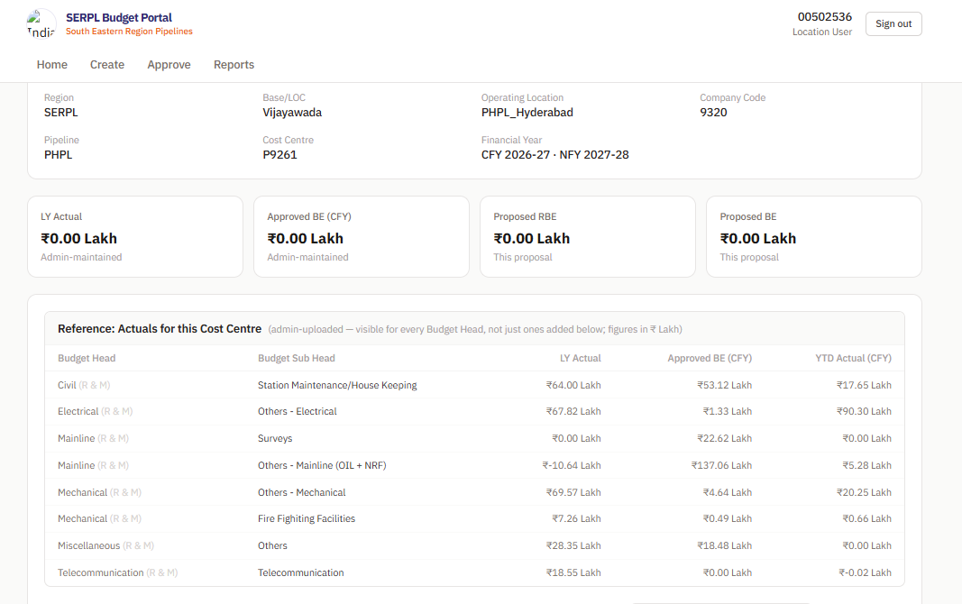

2. 2. Approve screen — Category Summary table
Current columns: Budget Head | Proposed RBE | Proposed BE | Items | View.
- Add LY Actual and Approved BE columns, per Budget Head, from admin-uploaded actuals for that cost centre (not just the cost-centre-level total in the top cards).
- Row list = union, not just heads with a submission: include any Budget Head present in admin-uploaded actuals for that cost centre even if the user proposed nothing this cycle. For such rows: Proposed RBE = 0.00 Lakh, Proposed BE = 0.00 Lakh, Items = 0.
- Confirm top cards (LY Actual/Approved BE/YTD Actual) already source correctly from admin-uploaded totals; if not, fix same as point 1.

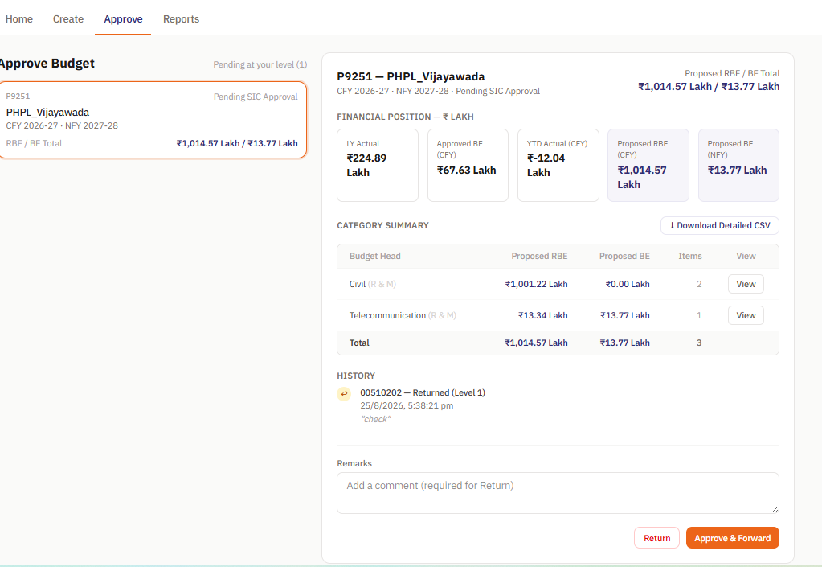

3. FY labels — replace CFY/NFY with actual years everywhere
(Create, Approve, Reports, anywhere these appear). Derive years dynamically from the cost centre's CFY/NFY, don't hardcode. Example if CFY=2026-27:
- LY Actual → "LY Actual (FY 25-26)"
- Approved BE (CFY) → "Approved BE (FY 26-27)"
- YTD Actual (CFY) → "YTD Actual (FY 26-27)"
- Proposed RBE → "RBE (FY 26-27)"
- Proposed BE (NFY) → "BE (FY 27-28)"

